My Unity License Was Activated Manually And Cannot Be Returned

我的Unity许可证是手动激活且不能被退回的

**Symptoms**

* I have am trying to reactivate Unity
* 我正在尝试重新激活Unity
* I am receiving this error:
* 我收到这个错误

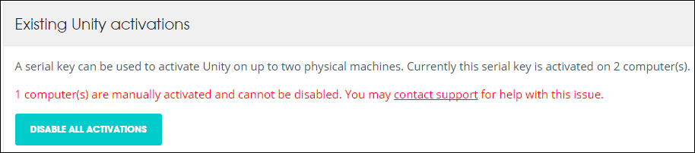

**Cause**

If you cannot activate due to an inconsistent internet connection, you may need to activate manually. Doing so, you may not be able to return your license via your web account.

如果由于Internet连接不一致导致无法激活，则您需要收到激活。这样，您可能无法通过您的网络账户退回您的许可证

**Resolution**

In this case you will need to contact Support. We can clear the existing activations for you, making it possible to reactivate successfully.

发生这种情况您需要联系支持人员。我们可以清除现有的激活，使您可以反激活成功。

Please get in touch with us [here](https://support.unity3d.com/hc/en-us/requests/new).

请在这里联系我们

When contacting Support, please provide your license serial number.

当联系支持时，您需要提供您的序列号。

**More Information**

Please read the [Manual Activation Guide](http://docs.unity3d.com/Manual/ManualActivationGuide.html) for further instructions on how to manually activate your license.

有关如何手动激活您的许可证 的进一步说明，请阅读[Manual Activation Guide](http://docs.unity3d.com/Manual/ManualActivationGuide.html)